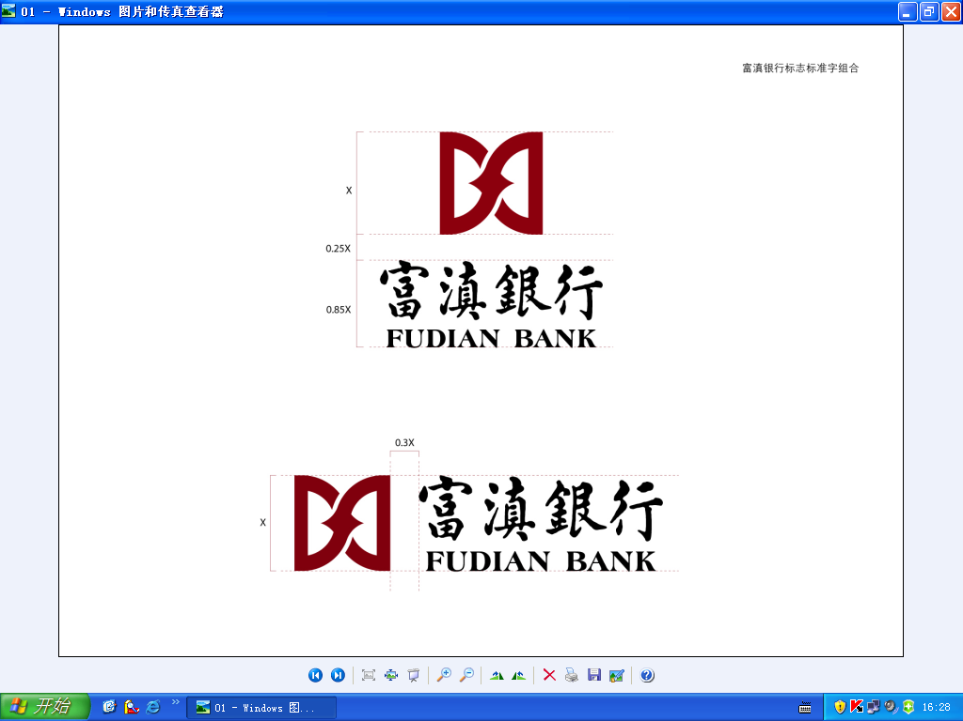
RMB Payment Routes
Receiving RMB payment at Fudian Bank Co., Ltd in P. R. China can be easy. Please fulfill this route with your banking information, and provide it to the remitter. If you have any queries, please do not hesitate to contact us. We would be pleased to be at your service.

欢迎阁下通过富滇银行查收人民币境外汇入款。请按指示填妥本页后提供给汇款人。如有疑问，请致电0871-63122127或0871-63122394进行咨询，我们将为您提供及时便捷的服务！

Intermediary Bank (中间行) :
Name : Bank of China Yunnan Branch
SWIFT Code : BKCHCNBJ640
A/C NO:135643493949
Account with Institution (收款人账户行)：
Name : Fudian Bank Co., Ltd.
SWIFT Code : KCCBCN2K
CNAP NO.313731010015

Beneficiary (收款人)：
A/C No. (账号) :
Name (户名) :
Details (附言) :

